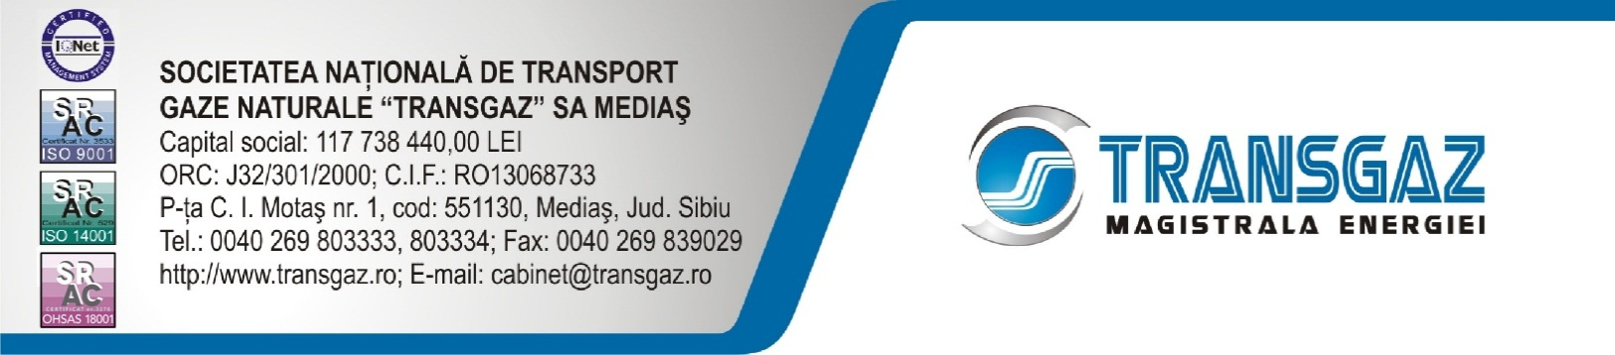

PRESS RELEASE
SNTGN Transgaz SA and SOCAR concluded a Memorandum of Understanding

Yesterday, 19.07.2016, SNTGN TRANSGAZ SA and SOCAR, the state oil company of the Republic of Azerbaijan signed a Memorandum of Understanding in Baku, Azerbaijan.

The Memorandum was concluded on the occasion of the meeting between Transgaz’ Chairman of the Board, Mr. Ion Sterian, the director of the European Funds and International relations Division, Mr. Ciprian Alic and SOCAR’s Chief Executive Officer, Mr. Rovnag Abdullayev.

H.E. Daniel Cristian Ciobanu, Romania’s Ambassador in Azerbaijan and Mrs. Ramona Nicole Mănescu, Member of the European Parliament also attended the meeting.

Subsequent to the meeting between the representatives of the two companies from the energy sector, well positioned on the regional market, the importance of a mutual support was identified which could underlie the development of strategic projects in view of the increase of the security of gas supply in the region.

In the context of the projects for the development of the national transmission network envisaged by Transgaz and taking into account SOCAR’s openness towards the development of a cooperation relationship with our company, the conclusion of a Memorandum of Understanding between the two companies would yield benefits and would strengthen the relation on multiple directions, in fields of strategic importance, in projects of common interest, without being limited to infrastructure projects in the energy field.

SOCAR may become a bridge for Transgaz towards the Republic of Azerbaijan and the Caspian Sea region and for SOCAR Transgaz may provide a connection to the relevant European institutions.

SNTGN Transgaz SA is the technical operator of the national gas transmission system and it is responsible for its operation under quality, safety, efficiency and environmental conditions.

Corporate Communication Department

