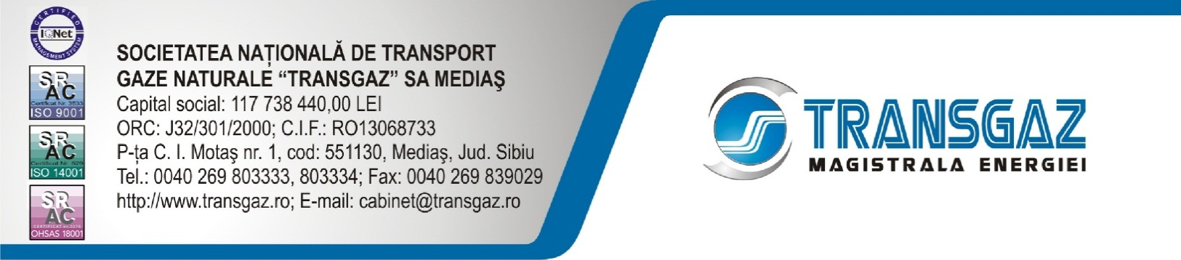

PRESS RELEASE

Today, 23.07.2016, the Romanian Minister of Energy, Mr. Victor Grigorescu together with the Bulgarian Minister of Energy, Mrs. Temenuzhka Petkova conducted an on-site visit at the site of the Giurgiu-Ruse gas interconnection pipeline. They met the representatives of the companies involved in the implementation of this project, Transgaz, Bulgartransgaz and the constructor Habau.
The Chairman of Transgaz’ Board of Administration, Mr. Ion Sterian and the Director of the Development Division, Mr. Ion Tataru presented the current status of the works related to the construction of the Giurgiu –Ruse interconnection pipeline.
The visit of the Romanian Minister of Energy to the construction site located in Marten-Bulgaria underlines, once more, the attention granted by the Romanian authorities to the Giurgiu –Ruse interconnection pipeline, considering its strategic importance for the energy security and for the safety of gas supply in the two countries.
The Romania-Bulgaria interconnection project is the only project enabling gas transmission from the Southern Corridor, Azerbaijan-Turkey-Greece towards Austria through the pipeline section on the territory of Romania. The gas transmission pipeline from Bulgaria to Austria, via Romania and Hungary (BRUA - PCI 7.15, Projects of common interest according to the first PCI List) is of outmost importance from the perspective of the security of gas supply in the region, generating the premises of the integration of the gas sources from the Southern Corridor in the markets from Central and Western Europe.
The project is financed by the European Union through the EEPR Program, according to the Financing Decision no. C (2010)5962-06.09.2010. The total value of the project is approximately EUR 24 million, of which EUR 8.6 million from European funds. The maximum amount of the grant is EUR 4.5 million for the Romanian section and EUR 4.1 million for the Bulgarian section.
The Project completion date according to the EC Financing Decision is 31.12.2016.

The project requires also the construction of two Gas Metering Stations (GMS) (in Giurgiu – Romania and Ruse - Bulgaria) so as to enable gas flow in both directions. At this moment the following objectives were completed: the gas metering station in Giurgiu and Ruse, the 5.1 km pipeline on the Romanian shore, the 15.4 km pipeline on the Bulgarian shore and the valve stations on both shores. Currently the directional drilling works are carried out for the two pipelines (main and back-up,) 2.1 km each.
SNTGN Transgaz SA is the technical operator of the national gas transmission system and it is responsible for its operation under quality, safety, efficiency and environmental conditions according to the national strategy established for gas transmission, international transit, gas dispatching, research and design in the gas field, in line with the national and European quality, performance, environment and sustainable development regulations.

CORPORATE COMMUNICATION DEPARTMENT

