GMOIS access registration and withdrawal procedure - Qualified Certificates

Versions

Version No. | Date | Updates | Page
1 | 13.07.2018 | Initial document | 1
2 | 11.12.2018 | Explication of the NU’s role and the Supplier’s role related to GMOIS /  completare procedura cu instalare certificate CA GMOIS | 1/
3 | 13.08.2020 | a certificate identifies a single role and cannot be associated with multiple roles | 2
4 | 13.08.2020 | Delete supplier role - no longer used

The access to the GMOIS platform is granted to companies which play at least one of the following roles on the Romanian gas market according to the Network Code and to the applicable regulations:

- Network user (NU)–ROL for capacity booking operations, nominations, renominations, VTP access, imbalances calculation
- Gas producer (PROD)
- Distribution system operator (OSD)
- Storage system operator (OSI)
- gas supplier (role used for gas exchange before gas enters the NTS) and after their exit from the NTS per import and extraction/storage points)
- Adjacent transmission system operator (ATSO)

In order to receive access rights companies have to take the following steps:

1. To acquire the qualified digital certificate for authentication in the GMOIS platform
2. To send the request to Transgaz – the Registration form signed by the legal representative of the requesting company.
3. To receive the confirmation of the registration of the GMOIS Platform access
4. To renew certificates
5. To withdraw access on the GMOIS platform
6. Helpdesk Transgaz
7. E-token and certificates issued by Transgaz

The access to the GMOIS platform is secured by means of the qualified digital certificates. Such certificates are acquired by the company who wishes to have access on the GMOIS Platform and is enrolled in the GMOIS platform according to the aspects below:

1. Acquiring the qualified certificate for authentication in the GMOIS portal

The qualified digital certificates will be acquired only from an accredited supplier of reliable certification services. The list of accredited suppliers may be viewed at the following Web address:

https://webgate.ec.europa.eu/tl-browser/#/tl/RO

Such list shall be updated on a regular basis.

The acquired certificate shall fulfill the following requirements:

- Version: V3
- Signature algorithm: sha256RSA
- Public Key: RSA(2048 Bits)
- Validity: 2 years
- The certificate to be able to be used at least for:
▪ Creating an electronic signature with legal value;
▪ Authentication into applications / servers;
▪ Identification of the owner of the certificate in the electronic environment;

A digital certificate cannot be used for multiple roles. Each certificate uniquely identifies the user and the attached role (UR, OSD, OSI, PROD.

2. Sending the request to Transgaz

In order to register the digital certificate in the GMOIS platform, the applicant shall take the following steps:

• Fill in the Registration Form, have it signed by the legal representative;
• Signed electronically (Digital Signature field);
• Attach a copy of the physical form of the digital certificate;
• Attach a copy of the company registration certificate;
• Attach a copy of the ANRE license (as applicable for: Natural gas suppliers, Natural gas producers, Distribution system operators, Storage system operators);
• If the NU role is envisaged to be used for the conclusion of capacity booking contracts, please fill in and send the Annex no.2 (to the Network Code for the National Gas Transmission System).

2.1) These documents together with the empowerment of the legal representative are sent by email (as attachments) at gmois@transgaz.ro

The subject of the email: “Digital certificate registration request– Name, Company_number”.

Where number – is the number of the token, (if the company already has a token then the number will be number 2).

Within two business days of receipt of the documents, the Operation Department will grant the access or refuse the request by notifying the applicant by email.

3. Receiving confirmation of enrollment of the certificate in the GMOIS Platform

Within 3 days of granting the right of access, Transgaz will notify the applicant by email at the address filled in the Registration form related to granting access on the GMOIS Platform.

4. Importing Transgaz' public certificates for the GMOIS Platform

The archive CertPubGMOIS.zip is downloaded from the location:

https://www.transgaz.ro/Downloads/CertPubGMOIS.zip

After unzipping the two certificates they are imported on the workstation. The import is achieved by double click on the certificate click on Install Certificate -> Next -> select Place all certificates in the following store -> press the button Browse then select Trusted Root Certification Authorities -> Ok -> Next -> Finish .(see the picture). Repeat the same procedure for the second certificate.

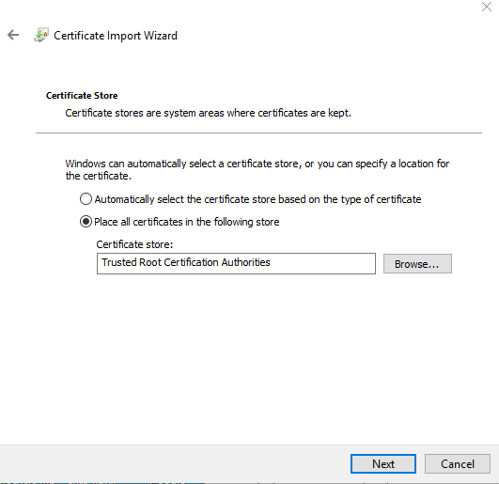

TRANSGAZ' recommendation:

From the digital certificate provider install the official e-tokens driver that is in use.

5. Renewal of the certificates
To renew the certificates, users will resume the procedure, updating the certificate on the electronic device according to the specifications of the qualified digital certificate provider.

Recommendations for the renewal of the digital certificates

1. Initiate the digital certificate renewal process early and receive the confirmation of your new certificate issue:

2. DO NOT download the certificate immediately from the token.

Fill in the registration form with the dates of the new certificate.

Send the registration form and a hard copy of the new certificate at gmois@transgaz.ro and the original at SNTGN Transgaz SA, Operation Department.

After having received the confirmation of the certificate registration:

3. Download the new certificate on the token (until then use the old certificate). For some certificates providers, this step may be different. After transmitting the public key to Transgaz through the digital signing of the registration form, in case of renewal, the enrollment will take up to 2 working days.

6. Withdrawing access to the GMOIS platform

Withdrawal of the access on the GMOIS platform of a qualified registered Certificate on the platform is made by Transgaz within one day of receipt of an address from the company requesting the withdrawal.
The address must contain the certificate identification data:

Public key
E-mail (E) address of the certificate owner
Common Name, CN
Organizational Unit, OU
Organization, O
Country, C
Locality, L

The letter signed by the legal representative of the company shall be sent by electronic means at the email address gmois@transgaz.ro

7. Helpdesk Transgaz

Following the enrollment of the certificate the user shall receive by email the access credentials for the platform https://helpdesk.transgaz.ro, used for the subsequent communication with the GMOIS users.

The documentation related to the use is available on Transgaz' webpage at http://www.transgaz.ro/sites/default/files/uploads/users/admin/manual_de_utilizare_helpdesk_transgaz. pdf

8. E-token and certificates issued by Transgaz

The electronic devices issued by Transgaz may still be used for access to the GMOIS Platform.

