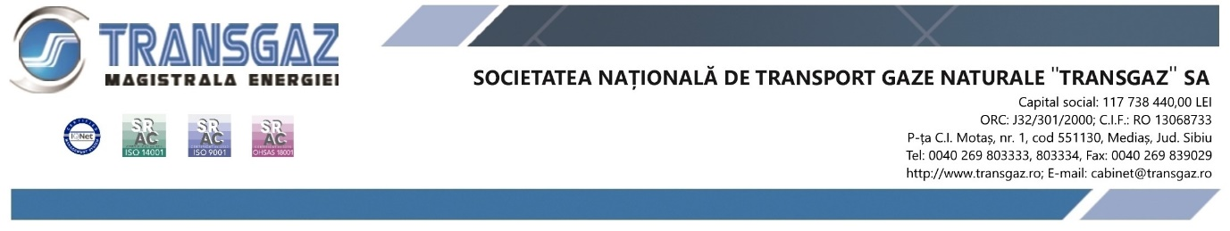
16 May 2022

EIB advisory and Romanian National Gas Transmission System Operator develop a decarbonisation strategy of the country’s natural gas network

PRESS RELEASE

The EUROPEAN INVESTMENT BANK (EIB) and SNTGN TRANSGAZ SA (Transgaz) have signed an agreement for the provision of advisory services to prepare and develop a decarbonisation strategy for Romania’s gas network.
Transgaz is a key player in the Romanian energy system, securing the access to secure, affordable and clean energy for Romanian citizens and companies. Transgaz aims to foster Romania’s clean energy transition, thus contributing to the country’s climate ambitions.
The technical assistance package delivered by EIB and external experts within the context of the European Investment Advisory Hub (EIAH), will include the preparation and development of a decarbonisation strategy for Transgaz to gradually transition to climate neutral activities.
Mr. Nicolae CIUCA, Prime-Minister of Romania stated: “The conclusion of this agreement with the European Investment Bank for the development of the decarbonisation strategy of SNTGN Transgaz SA, the Operator of the Romanian National Gas Transmission System, is an important step forward for Romania in terms of its goals for the transition to a green economy and, at the same time, it paves the way for similar actions as far as other state companies and institutions are concerned. I take this opportunity to congratulate Transgaz and the European Investment Bank for the efforts made in order to meet Romania’s climatic neutrality objectives.”
Mr. Christian KETTEL THOMSEN, EIB Vice-President, said: “Projects such as this one are particularly timely in the current geo-political context. We are happy to extend the cooperation with Transgaz and to provide technical assistance in the development of their decarbonisation strategy. I am confident that our support will accelerate the company’s transition to a carbon neutral business model and contribute to achieving Romania’s and Europe’s climate action goals.”
Mr. Ion STERIAN, Transgaz’ Director General, commented: “The development of Transgaz’s decarbonisation strategy confirms once again our commitment to transitioning to a climate neutral activity. We are glad that in this important endeavour, the EIB is supporting us, as the EU’s Climate Banks. It is an additional proof of our company’s commitment to the sustainable development of Romania’s economy and energy system.”
EIB experts will work alongside Transgaz staff to analyse the status of Romania’s gas network as well as its GHG emission inventory and climate vulnerability policies.
The strategy will include measures to help reduce emissions within the network, as well as adaptation criteria to mitigate climate risks, highlighting investment needs and relevant financing sources where relevant. In the context of another advisory assignment by the EIAH, Transgaz recently completed a Strategic Environmental Assessment related to the ten-year Network Development Programme for the National Gas Transmission System. This assessment laid the ground for the decarbonisation strategy.

COMMUNICATION DEPARTMENT

Background information
ABOUT TRANSGAZ

SNTGN TRANSGAZ is the technical operator of the National Natural Gas Transmission System and ensures the performance in terms of efficiency, transparency, safety, non-discriminatory access and competitiveness of the national strategy established for domestic and international transmission, natural gas dispatching, research and design in the field of natural gas transmission, in compliance with the national and European legislation and standards of quality, performance, environment and sustainable development.

ABOUT EIB
- The European Investment Bank (EIB) is the long-term lending institution of the European Union owned by its Member States. It makes long-term finance available for sound investment in order to contribute towards EU policy goals.
- Last year the European Investment Bank Group provided EUR 907 million for new investment across Romania. The EIB Group’s engagement in the country included financing for construction of two new regional hospitals, modernisation of the national electricity network to harness renewable energy and deployment of smart meters, improving energy efficiency and scaling up high-impact business investment.
- Over the last 31 years, the EIB Group has provided more than EUR 18 billion for public and private sector investment across Romania, out of which over EUR 1.2 Bn for energy investments.

The European Investment Advisory Hub (EIAH) is a partnership between the European Investment Bank Group and the European Commission under the Investment Plan for Europe. The EIAH is designed to act as a single access point to various types of advisory and technical assistance services. It supports the identification, preparation and development of investment projects across the European Union. Building on the success of the EIAH and other advisory programmes, the EIB and the European Commission agreed to provide technical, financial and strategic expertise to project promoters, regional and national authorities, and financial intermediaries under the InvestEU Advisory Hub.

FOTO

